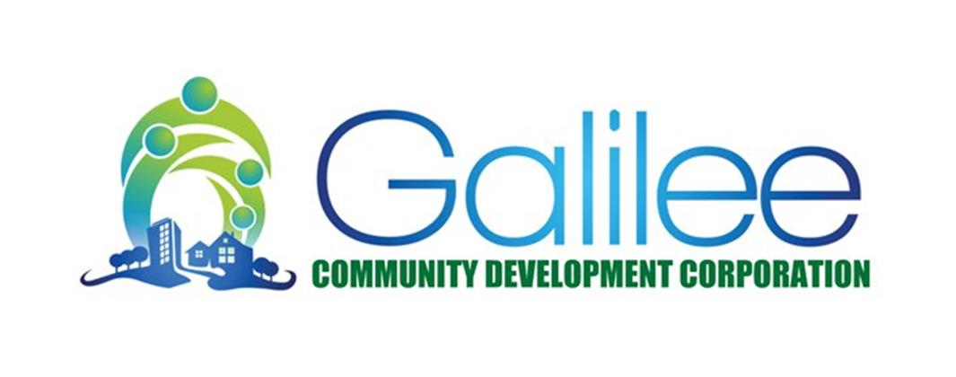


“We Won’t Tell You What To Think, We Simply Insist That You Do.”

Men Under Construction (MUC) is a ”rites of passage”, 13 week, life skills program designed for males ages 13-18. The program provides specific guidance for African American males, with a component that addresses alternative actions when interfacing with the criminal justice system. The program focuses on instilling principles of leadership and self-empowerment through education and offers a variety of hands on experiences. There is no cost to participate.

MUC covers such topics as personal money management, public speaking, table etiquette, picking a college, successful job interviews, rejecting peer pressure, dealing with authority figures, personal health and hygiene and various other topics. The program culminates with a “rites of passage” graduation ceremony.

For further information you may leave a message for the MUC Program Manager, Demitri Kornegay, with the Galilee Community Development Corporation office, (240) 455-4208. This interest application may be returned via email or to the GCDC office at the above address.

=======================================================================

MUC Interest Form

Name: ______________________________________________ ____________ Age: _________
(Please Print)

Address: ___________________________________________________________________________

School: _________________________________________________ Grade: ______________

Parent or Guardian: ________________________________

Phone Number: _________________________________

Parent Email Address: _________________________________

I would like for my son to participate because _____________________________________________

____________________________________________________________________________________

_______________________________________________________________________________________

